National Survey of Working Women Toolkit
www.ufcw.org/WWsurvey

The National Survey of Working Women is designed to capture a multifaceted picture of the lives of working women across the country, both union and non-union. It is an opportunity to educate advocates and the media on the challenges working women face, whether it is on the job, balancing work and family, or leading in our communities. It is another tool to help us tell the story of our UFCW family and hard working families across the country.

The survey will be open from October 27-December 4. Over the next month, we ask that you use this digital toolkit to help spread the word about the survey to your community. Below you will find sample tweets, Facebook posts, branded graphics, and e-mail language.

Please contact Maura Pond, mpond@ufcw.org, with any questions on the digital toolkit.

Project Timeline
The following is a rough timeline of the AFL-CIO digital activities. Please feel free to adjust as necessary to suit your existing campaigns and priorities.
10/27/15 | 1st Email Blast: Survey Launch
11/2/15 | AFL-CIO SMS Blast
11/9/15 | Spanish Language Survey Available
11/9/15 | 2nd Email Blast
11/23/15 | 3rd Email Blast
12/2/15 | 4th Email Blast
12/4/15 | Survey Closes
~12/18/15 | Preliminary Report draft
2/22/16 | Report Results to AFL-CIO Executive Council Committee on Women and Work
3/2016 | Release Final Report

Facebook

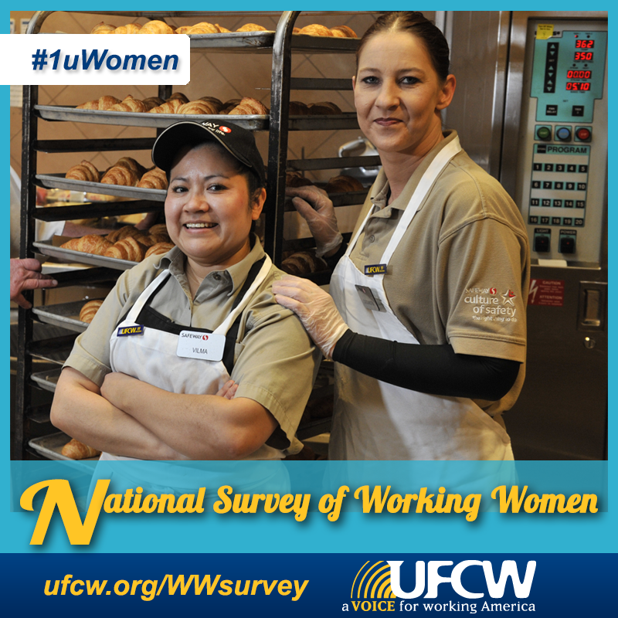

Equal pay? Paid family leave? Unfair scheduling? What issues are important to you in the workplace?

Take the survey----> www.ufcw.org/WWsurvey

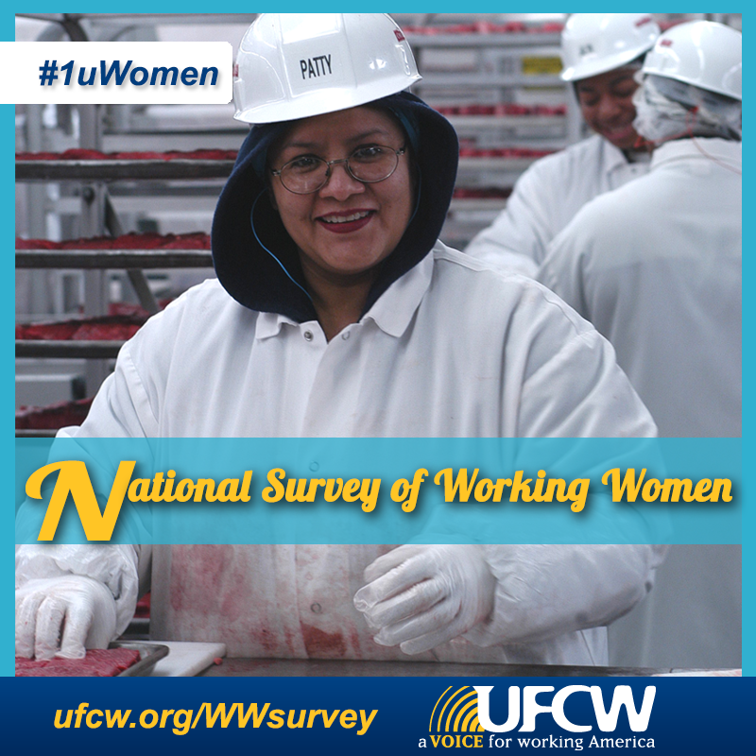

Help us bring the voices of real working women to the table.

Speak out about the issues most important to you: www.ufcw.org/WWsurvey

Twitter

Hey working women! What stands between you and prosperity? Take our survey at www.ufcw.org/WWsurvey #1uWomen

What issues are important to women in the workplace? Text WOMEN to 235246 to tell your story. #1uWomen

Care about paid leave for working families? Take the National Survey for Working Women www.ufcw.org/WWsurvey #1uWomen

Help bring the voices of real working women to the table. Take the survey: www.ufcw.org/WWsurvey #1uWomen

Care about helping women thrive in the workplace? Take the National Survey for Working Women www.ufcw.org/WWsurvey #1uWomen

Attn working women! What issues matter most to you in the workplace? Share your thoughts www.ufcw.org/WWsurvey #1uWomen

Care about the challenges women face in the workplace? Tell your story: www.ufcw.org/WWsurvey #1uWomen

Retweet to share this important survey with the working women in your life: www.ufcw.org/WWsurvey #1uWomen

Hey #1uWomen! Share your thoughts about issues important to women in the workplace. Take the survey www.ufcw.org/WWsurvey #1uWomen

Help us understand the needs of women in the workplace. Take the survey----> www.ufcw.org/WWsurvey #1uWomen

Working Women: Make your voice heard on the issues important to you. Take this national survey----> www.ufcw.org/WWsurvey #1uWomen

Balancing work and family? Paid leave? What issues matter most to you? Take the survey----> www.ufcw.org/WWsurvey #1uWomen

Equal pay? Unfair scheduling? Speak out about the issues that matter to you. Take the survey----> www.ufcw.org/WWsurvey #1uWomen

E-mail

(If possible, you may replace the Sender with a woman from your leadership or an active rank and file member.)

Sender: United Food and Commercial Workers Union

Subject: What working women want

{{ FirstName | default: "Friend" }},
It’s no secret that women face unique obstacles balancing family and work. But the truth is that women are not some special interest group. We want the same thing all Americans want: fair pay and an economy that works for everyone.
Too often, politicians, the media and pop culture write the narrative about what working women want. It’s time we speak for ourselves.

Take our Working Women's survey and let the world know what matters to women at work.
Women are poised to lead, both in our communities and on the job. We know what it takes to get the job done. Yet, too many of us still get stuck below the glass ceiling.
We want to hear from you. Tell us what’s standing in your way. What would make your life better--at home and at work?
It’s time for working women to use our own voice to tell America our story. The UFCW with the AFL-CIO will use the anonymous responses we gather to publish a written report, bringing the voices of real working women to the table.
Spend just a few minutes of your time and share it with your coworkers and friends. Together we can change the rules to create a better life for all families!

Join our Working Women's survey and let the world know what matters to women at work.

In Solidarity,
United Food and Commercial Workers Union

